Student Details | Information
Student Names | Jainam Jain  Vrushan Patil  Dhanush Chowke  Aditya Tambe  Vivek Jaiswal
Roll No. | 23108B0084  23108B0079  23108B0080  23108B0077  23108B0082
Class / Division | B.E. Semester VII, Division B
Department | Electronics and Computer Science, Vidyalankar Institute of Technology
Project Title | Socio-Economic & Demographic Analysis of Indian Festivals
Faculty Guide | Prof. Uma Jaishankar
Academic Year | 2026-27

Project Flow
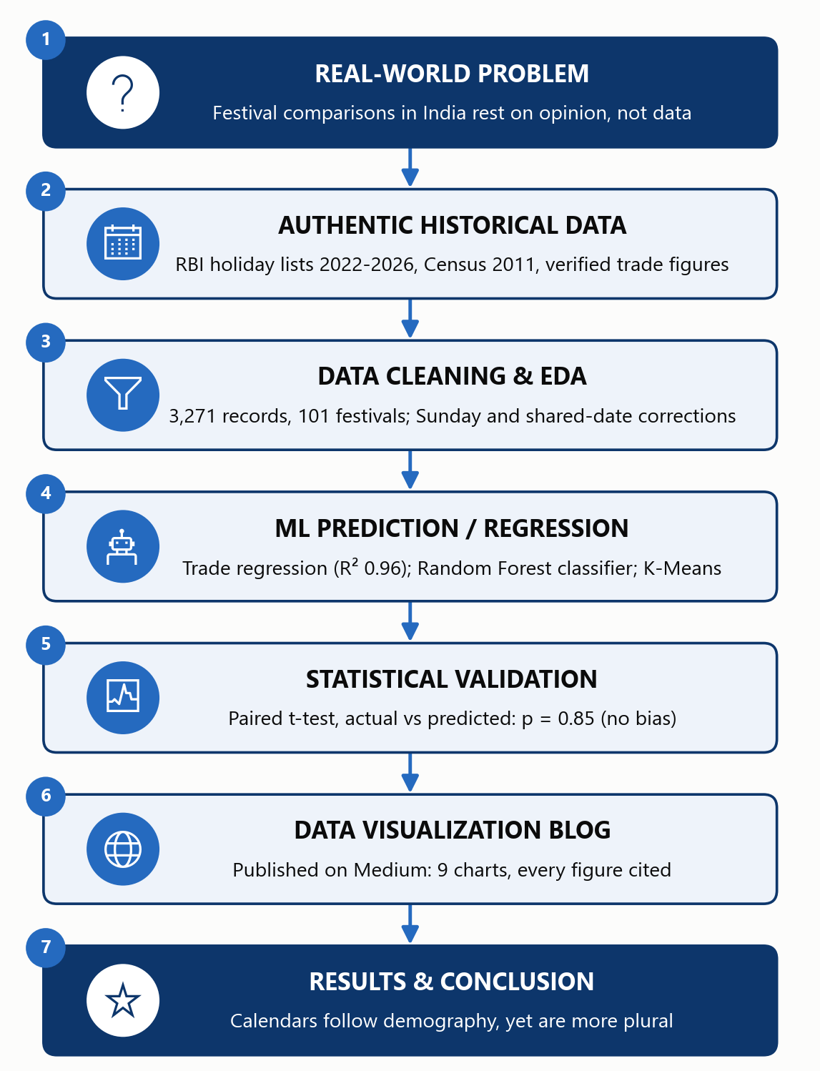

Project Overview
India celebrates hundreds of festivals, but most comparisons between them rest on opinion. This project builds an authentic, source-linked dataset of officially recognised festivals (2022-2026), uses machine learning to predict festive trade and to classify festivals, validates the predictions statistically, and communicates the findings as a public data blog. No synthetic data is used: every record carries the link it came from.
Part | Component | Key Question
1 | Dataset + Source | What data do we have and is the source credible?
2 | ML Prediction / Regression | Can historical data be used to predict the target?
3 | Statistical Validation | Are the observed findings statistically supported?
4 | Visualization as a Blog | Can the data be communicated as a data story?
5 | Results + Conclusion | What did we finally learn?

PART 1 — Dataset with Source
Objective: Establish the relevance, authenticity and structure of the historical dataset.

1.1 Problem Statement
Real-world problem: information about Indian festivals is scattered and anecdotal, which leads to biased representations, missing comparisons between states and faiths, and an unclear picture of their economic weight.
Project problem statement: To collect authentic multi-faith festival data for India, measure when, where and whose festivals are officially recognised, predict festive trade from historical figures, test the findings statistically, and publish them as a balanced, evidence-based data story. Outcomes studied: (a) festive trade in INR crore (numerical target, regression) and (b) the tradition group of a festival (categorical target, classification).

1.2 Dataset Source
Parameter | Details
Dataset Name | Indian Festival Holiday Observations (RBI holiday matrix), with Census 2011 and a verified festive-trade table
Source / Website | Reserve Bank of India - Holidays under the Negotiable Instruments Act (primary)  Census of India 2011, Table C-01; DoPT holiday order F.No.12/2/2023-JCA; CAIT and verified news (trade figures)
Working URL | https://www.rbi.org.in/Scripts/HolidayMatrixDisplay.aspx  https://censusindia.gov.in/nada/index.php/catalog/11361  Project data and code: https://github.com/iJainamJain/indian-festivals-data-analysis
Date Accessed | 05 October 2026 (RBI); 28 September 2026 (Census, trade figures)
Number of Records | 3,271 festival-holiday observations (from 3,221 RBI office-date rows)  101 festivals; 29 states/UTs; 78 verified spending and crowd figures
Number of Variables | 24 in the main table; 37 in the festival table; 17 in the trade table
Target Variable | Regression: festive trade value (INR crore)  Classification: tradition group of a festival (4 classes)
Input Variables | Regression: year, festival, reported-or-projected flag  Classification: month, date drift, number of states, share in each of 6 regions, holiday length, shared-date share
Time Period | Holidays 2022-2026; trade figures 2018-2026; Census 2011
Geographic Coverage | India: 29 states/UTs through all 34 RBI regional offices

1.3 Source Evidence
The screenshot below is the original source: the RBI holiday matrix for all regional offices (October 2025 shown). Working URL: https://www.rbi.org.in/Scripts/HolidayMatrixDisplay.aspx
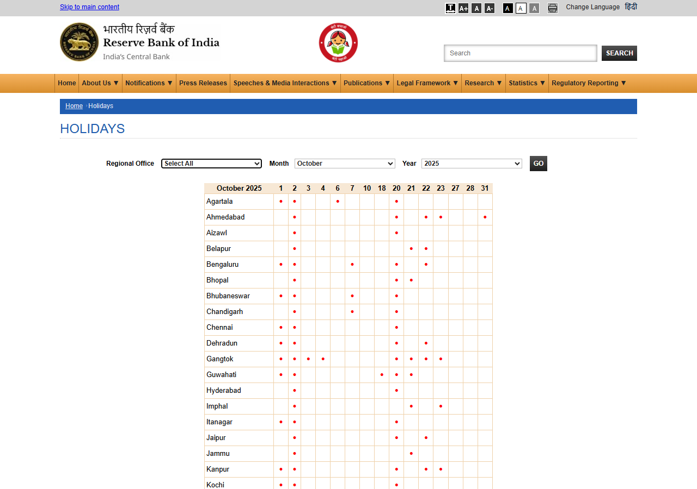
Source evidence: RBI holiday matrix, captured 13 October 2026.
Why the source is reliable and appropriate:
- RBI is India's central bank. Its list is the legal record of bank holidays notified by each state under the Negotiable Instruments Act.
- It covers every faith and every state in one consistent format, for several years, so states and traditions can be compared fairly.
- It is updated when holidays are declared later in the year (elections, heavy rain, state mourning), and those dates are in our data.
- Population figures come from the Census of India, and trade figures from CAIT surveys and verified news; each trade figure was opened and confirmed on its source page.
- Limits we state openly: RBI lists no Sunday dates (corrected for), it prints one combined label per date (handled by evidence rules), and festivals with no bank holiday are not covered.

1.4 Data Dictionary
Variable | Description | Data Type | Unit | Role
X1 year | Year the figure or holiday refers to | Integer | Year | Feature
X2 festival | Canonical festival name (101 festivals) | Categorical | - | Feature
X3 is_projection | 1 if the trade figure is a pre-event estimate, 0 if reported after the festival | Binary | 0 / 1 | Feature
X4 modal_month | Month in which the festival usually falls (encoded as sine and cosine) | Numeric | Month | Feature
X5 date_drift_days | How much the festival's date moves between years (fixed vs lunar calendar) | Numeric | Days | Feature
X6 expected_states_per_year | Number of states recognising the festival in a year | Numeric | States | Feature
X7 region_share_* | Share of the festival's recognition in each of 6 regions | Numeric | Proportion | Feature
X8 mean_holiday_days | Average length of the holiday | Numeric | Days | Feature
X9 recognition_weight | Credit for a festival at an office on a date (1 = confirmed, less if a shared date is ambiguous) | Numeric | 0 to 1 | Feature
Y1 festive trade value | Trade attributed to the festival (CAIT and cited sources) | Numeric | INR crore | Target (regression)
Y2 tradition group | Hindu / Muslim-Christian / Tribal-Indigenous / Other | Categorical | - | Target (classification)

1.5 Data Pre-processing
- Missing-value treatment: the cleaned tables have no missing values. The gap that matters is structural: RBI lists no Sunday dates, so each festival is averaged only over the years it could be listed.
- Duplicate removal: 2 duplicate office-date rows were removed; variant spellings of the same festival (for example Dussehra, Dusshera, Dasara) were merged into 101 canonical festivals.
- Outlier treatment: no records were deleted. Trade values span Rs 3,000 crore to Rs 6.05 lakh crore, so the regression uses the log of trade; non-parametric tests are used for skewed variables.
- Encoding categorical variables: festival is one-hot encoded for the regression; month is encoded as sine and cosine; calendar type is a 0/1 flag.
- Feature scaling: features are standardised (z-scores) for Logistic Regression and K-Means; Random Forest needs no scaling.
- Train-test split: classification uses repeated stratified 5-fold cross-validation (20 repeats); regression uses leave-one-out validation and a time-based hold-out (train up to 2025, test on 2026).

PART 2 — ML Algorithm for Prediction or Regression
Objective: Use historical data to build an appropriate machine learning model and generate predictions.

2.1 Select the ML Problem
Problem Type | Possible Algorithms | Target Type
Classification | Logistic Regression, Decision Tree, Random Forest, SVM, KNN | Categorical
Regression | Linear Regression, Decision Tree Regression, Random Forest Regression | Numerical
Time-series Forecasting | ARIMA / suitable forecasting model | Time-dependent numerical
Selected: Regression (festive trade, numerical target) as the main prediction task, using a log-linear regression. A Random Forest classification model (tradition group, categorical target) is reported as the second model.

2.2 Model Development
- Inputs and target. Regression: year, festival and a reported-or-projected flag predict log(trade in INR crore). Classification: 14 calendar and geography features predict the tradition group.
- Train and test. Regression: 15 historical figures up to 2025 for training, with leave-one-out validation; the 2026 figures are held out. Classification: repeated stratified 5-fold cross-validation on 101 festivals.
- Training. Linear regression on log(trade) with a separate term for each festival; Random Forest (500 trees, balanced class weights) compared with Logistic Regression and a majority-class baseline.
- Predictions. Every historical point is predicted by a model that never saw it (leave-one-out), then the model predicts the 2026 figures and forecasts 2026 trade for each festival.
- Model and assumptions. Trade grows at a steady percentage rate (estimated at 36% a year), festivals differ by a fixed level, and pre-event projections may differ systematically from reported figures. With 15 data points the model is deliberately simple.

2.3 Model Evaluation
Regression (festive trade), evaluated on leave-one-out predictions:
- MAE = Rs 19,535 crore; MSE = 1.29e+09 (crore squared); RMSE = Rs 35,908 crore
- R-squared = 0.961 on the rupee scale and 0.963 on the log scale; mean absolute percentage error = 20.2%
- Time-based hold-out (2026): mean absolute percentage error = 13.1%
Classification (tradition group of a festival), repeated 5-fold cross-validation:
- Random Forest: accuracy 0.51, precision 0.47, recall 0.47, F1-score 0.45 (macro averages)
- Logistic Regression: accuracy 0.48, F1-score 0.43. Majority-class baseline: accuracy 0.45, F1-score 0.15
- Per class (Random Forest): Abrahamic F1 0.44; Hindu F1 0.67; Other F1 0.19; Tribal/Indigenous F1 0.55
- ROC curve not reported: with four classes and about 100 festivals, the confusion matrix is the clearer summary.
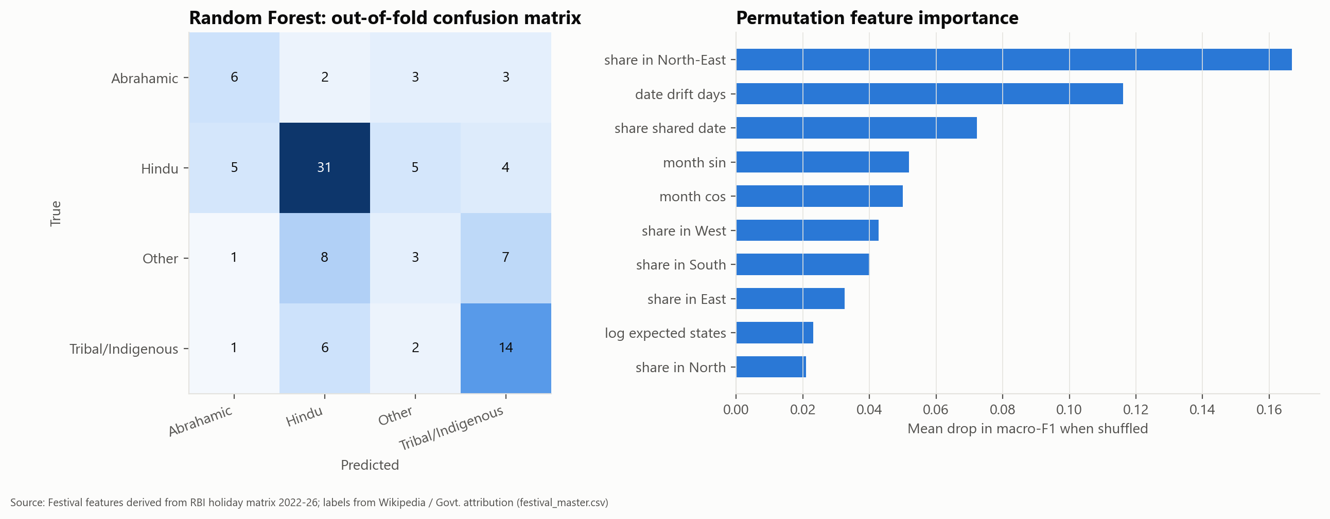
Confusion matrix (left) and permutation feature importance (right) for the Random Forest.

2.4 Actual vs Predicted Results
Sample | Actual Y (INR crore) | Predicted Y (INR crore) | Error
1. Diwali 2021 | 125,000 | 209,389 | +84,389 (+68%)
2. Diwali 2023 | 375,000 | 287,081 | -87,919 (-23%)
3. Diwali 2024 | 425,000 | 412,920 | -12,080 (-3%)
4. Diwali 2025 | 605,000 | 541,860 | -63,140 (-10%)
5. Ganesh Chaturthi 2024 | 25,000 | 33,384 | +8,384 (+34%)
6. Ganesh Chaturthi 2025 | 45,000 | 33,699 | -11,301 (-25%)
7. Holi 2024 | 50,000 | 58,226 | +8,226 (+16%)
8. Holi 2025 | 60,000 | 51,524 | -8,476 (-14%)
9. Karva Chauth 2023 | 15,000 | 15,777 | +777 (+5%)
10. Karva Chauth 2024 | 22,000 | 20,494 | -1,506 (-7%)
11. Karva Chauth 2025 | 28,000 | 28,695 | +695 (+2%)
12. Raksha Bandhan 2018 | 3,000 | 1,471 | -1,529 (-51%)
13. Raksha Bandhan 2023 | 10,000 | 13,629 | +3,629 (+36%)
14. Raksha Bandhan 2024 | 12,000 | 12,958 | +958 (+8%)
15. Raksha Bandhan 2025 | 17,000 | 17,012 | +12 (+0%)
16. Raksha Bandhan 2026 (hold-out) | 30,000 | 23,046 | -6,954 (-23%)
17. Holi 2026 (hold-out) | 80,000 | 77,716 | -2,284 (-3%)

Actual vs Predicted graph (points on the dotted line would be perfect predictions):
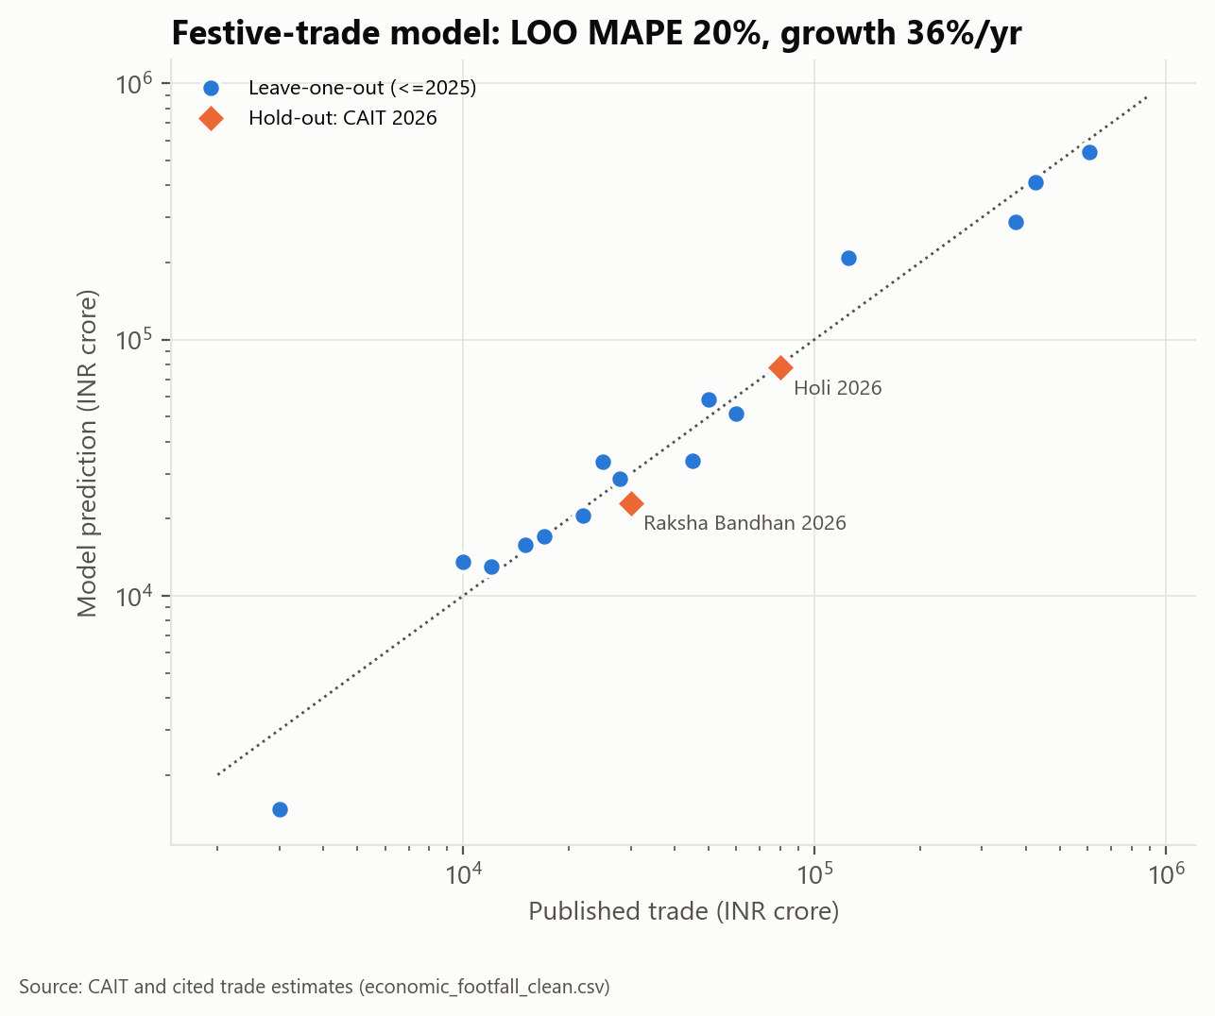
Actual vs predicted festive trade: leave-one-out predictions and the 2026 hold-out.

PART 3 — Statistical Validation of ML Results
Objective: Use an appropriate statistical method any one to determine whether the observed relationships, differences or predictions are statistically supported.
Method | Use When | Example
t-test | Comparing two means / paired actual vs predicted values | Test whether mean prediction error differs significantly from zero
ANOVA | Comparing means across 3 or more groups | Compare errors/performance across several models or groups
Chi-square | Testing association between categorical variables | Food type vs adulteration status
ARIMA | Forecasting time-series data | Predict future monthly values from historical observations

3.1 Statistical Test Selected
Selected test: Paired t-test (actual vs predicted). Reason: each festival-year has one actual and one predicted trade value, so the two are paired. The test checks whether the model is systematically too high or too low. Values are compared on the log scale because trade spans three orders of magnitude; the differences are consistent with a normal distribution (Shapiro-Wilk p = 0.73).

3.2 Hypotheses
H₀ (Null Hypothesis): The mean difference between predicted and actual log festive trade is zero (the model has no systematic bias).
H₁ (Alternative Hypothesis): The mean difference is not zero (the model systematically over- or under-predicts).

3.3 Statistical Results
Parameter | Result
Significance level (α) | 0.05
Test statistic | t = -0.188 (mean difference -0.014 log units, about -1.4%; 95% CI -0.175 to +0.147)
Degrees of freedom | 14 (n = 15 paired values)
p-value | 0.853
Decision | Fail to reject H₀
Interpretation | There is no evidence of systematic bias: on average the predictions are neither too high nor too low. Individual errors still average about 20%, and with only 15 points the test cannot detect a small bias.

Supporting tests from the exploratory analysis (full tables in outputs/stats):
- Chi-square goodness of fit: festival holidays are not spread evenly across months (chi-square = 825, df = 11, p < 0.001); peaks in April, October and March.
- Chi-square test of independence: a festival's season does not depend on its tradition (permutation p = 0.78).
- Spearman correlation: each faith's share of a state's holidays rises with its population share (rho 0.38 to 0.66; all significant after Holm correction).
- Kruskal-Wallis: festival holidays per state do not differ between the six regions (p = 0.80).

PART 4 — Visualization of Data as a Blog for Publication
Objective: Convert the technical analysis into an engaging, evidence-based data story suitable for publication.

4.1 Suggested Blog Structure
Section | What we included
Title / Hook | "What India's Bank-Holiday Calendar Reveals About How the Country Celebrates". Opens with: ask ten people which festivals matter most and you get ten answers.
Introduction | Why opinion-based comparisons are biased, and three questions: when and where India celebrates, whose festivals are recognised, and what they are worth.
The Data | RBI holiday lists 2022-2026 (3,271 records, 101 festivals, 29 states), Census 2011, 78 verified trade and crowd figures; how Sundays and shared dates were handled; what the data cannot see.
Visual Story | 9 charts: month-by-tradition bars, state map, state-by-month heatmap, holiday share vs population share, diversity map, state-group map, trade trend, Diwali sector split, crowd density. 4 interactive versions.
Conclusion | The calendar peaks in April, October and March; calendars follow demography yet are more plural than the population; four north-eastern states are distinct; festive trade is growing but measured unevenly.
References | 10 numbered sources: RBI, Census of India, DoPT, CAIT, All India Radio, verified news, NRF, gov.cn, GASTAT, City of Munich, and the project repository.

4.2 Recommended Visualizations
- Histogram / distribution plot: reach of festivals, holidays per state and trade values (Fig. 4.1).
- Box plot: festival holidays per state by region (Fig. 4.2).
- Bar chart: festival holidays by month and tradition (Fig. 4.3); Diwali 2025 sector split.
- Scatter plot: holiday share vs population share for each faith (Fig. 4.4).
- Correlation heatmap: state-level holiday and Census variables (Fig. 4.5); state-by-month heatmap.
- Time-series plot: festive trade by year for five festivals (Fig. 4.6).
- Actual vs Predicted plot: festive-trade regression (Part 2.4).
- Confusion matrix: Random Forest tradition classifier (Part 2.3). Also a state map of festival holidays (Fig. 4.7).
Blog / publication link: https://medium.com/@i.jainamjain/what-indias-bank-holiday-calendar-reveals-about-how-the-country-celebrates-97c99917b2d3
Blog title: What India's Bank-Holiday Calendar Reveals About How the Country Celebrates (Medium, published 28 September 2026)
Public response: 0 external reactions and comments logged so far against a target of 40; 0 comments answered. Only readers outside the institute are counted, each with a screenshot.
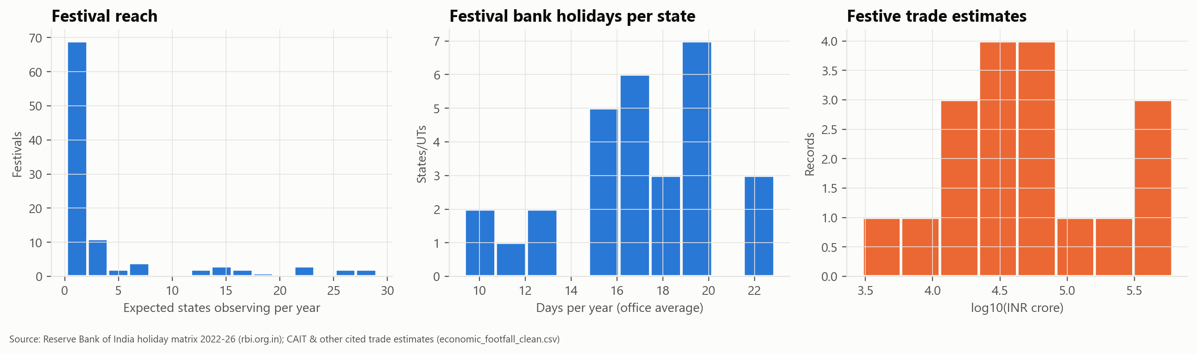
Fig. 4.1 Distributions of festival reach, holidays per state and trade estimates.
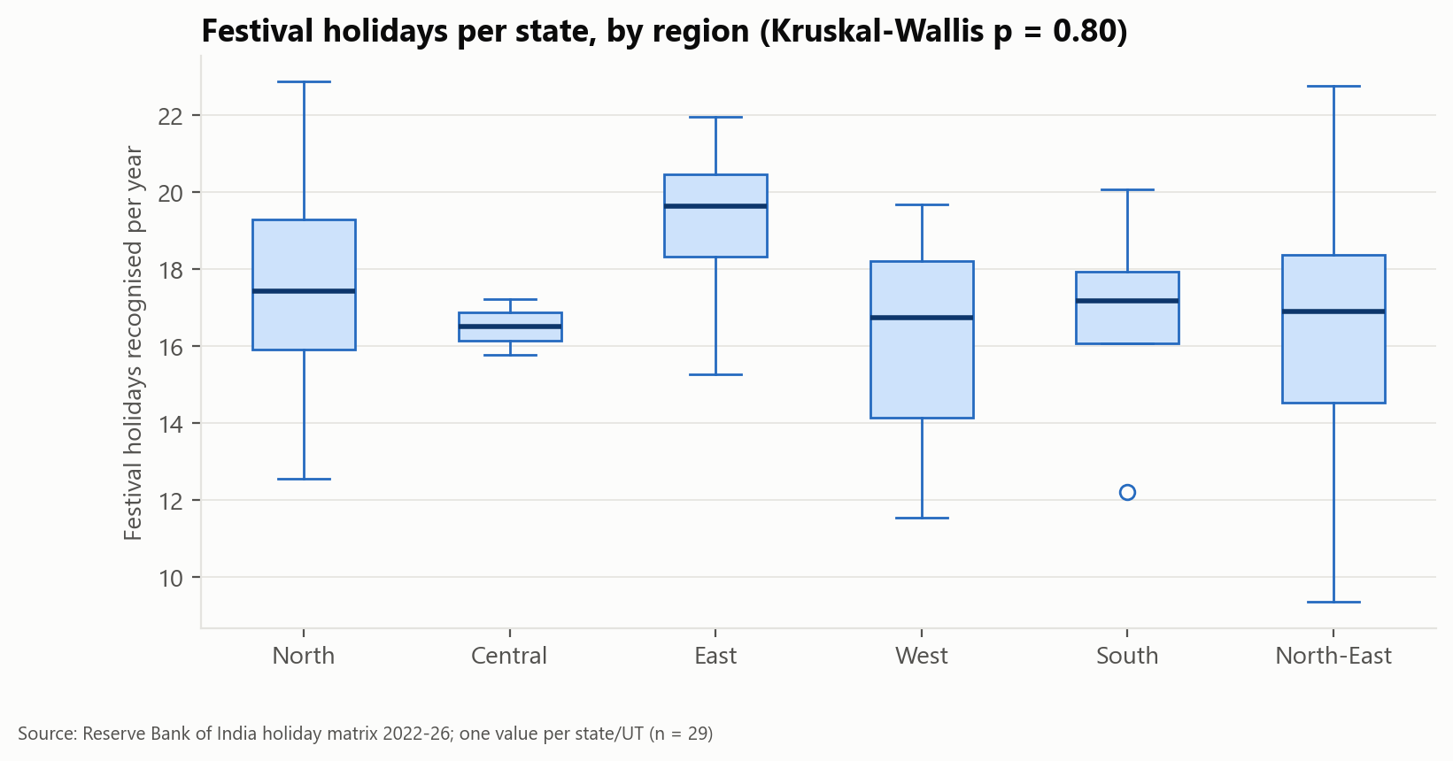
Fig. 4.2 Festival holidays per state, by region.
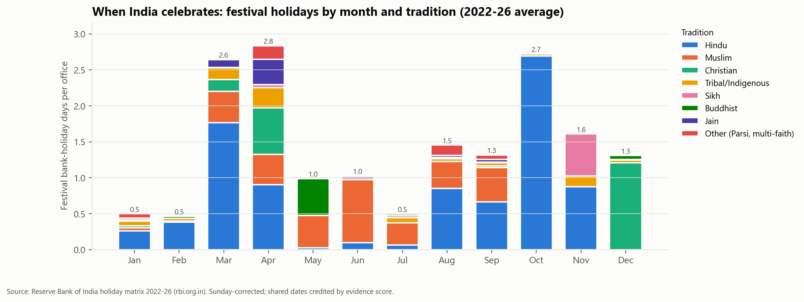
Fig. 4.3 Festival holidays by month and tradition.
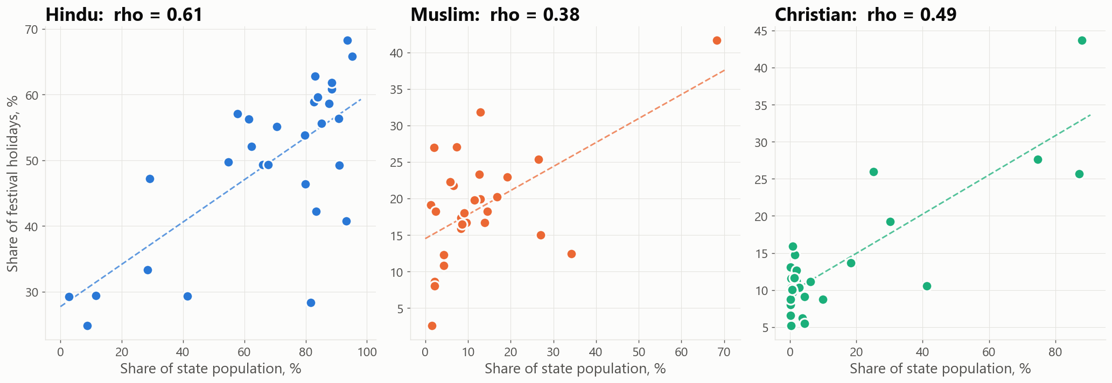
Fig. 4.4 Holiday share vs population share (each dot is a state).
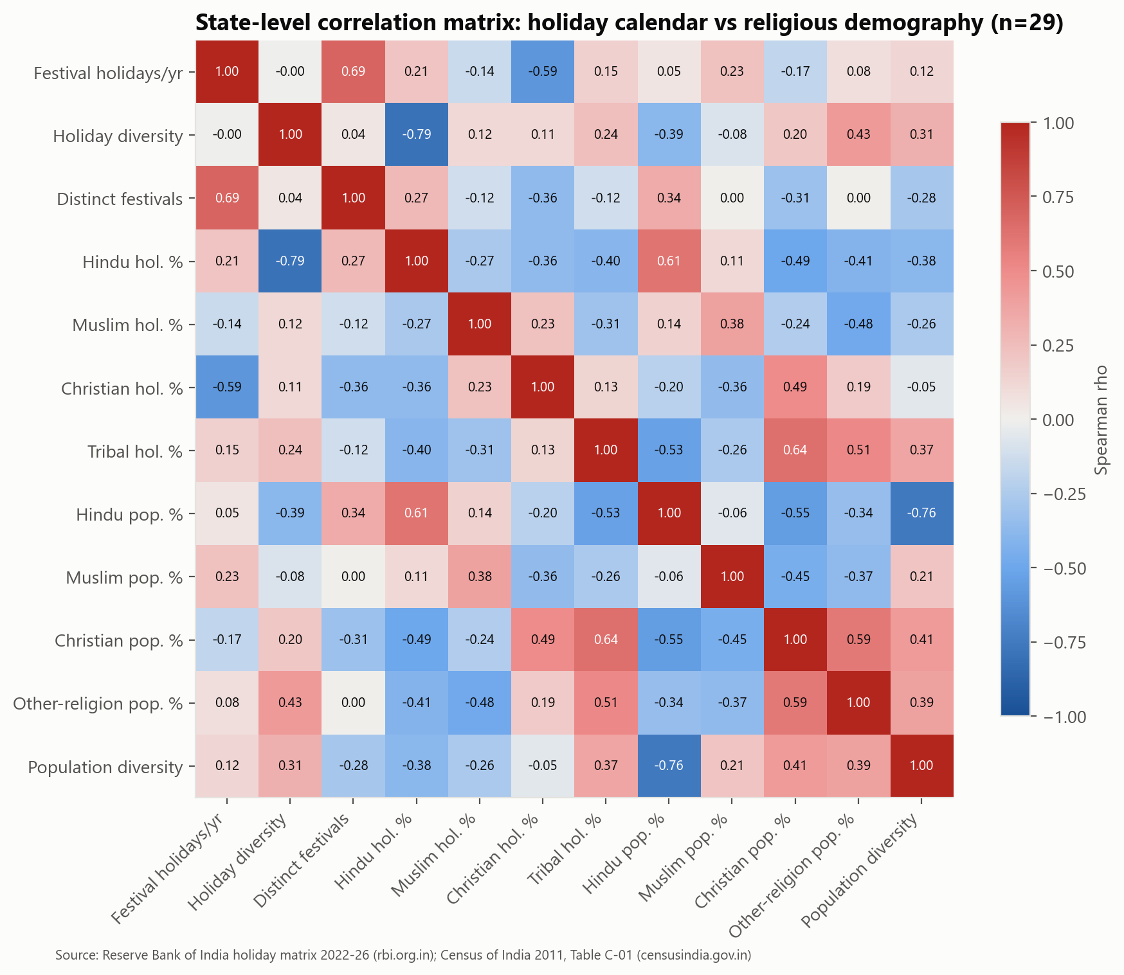
Fig. 4.5 Spearman correlation heatmap of state-level variables.
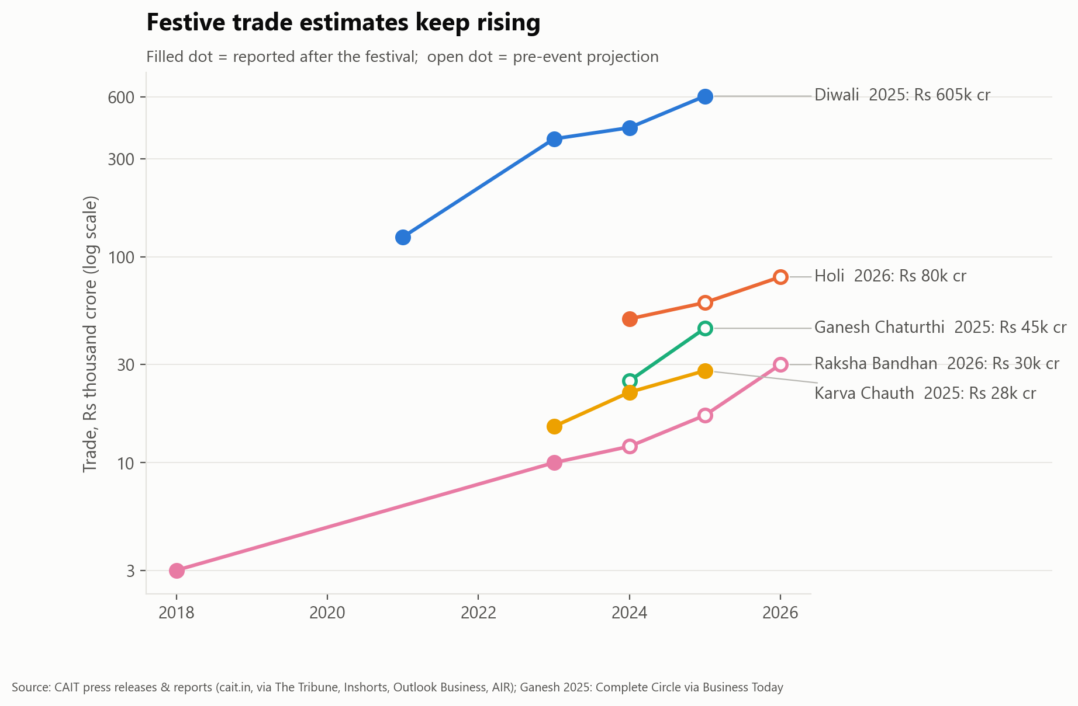
Fig. 4.6 Festive trade estimates by year.
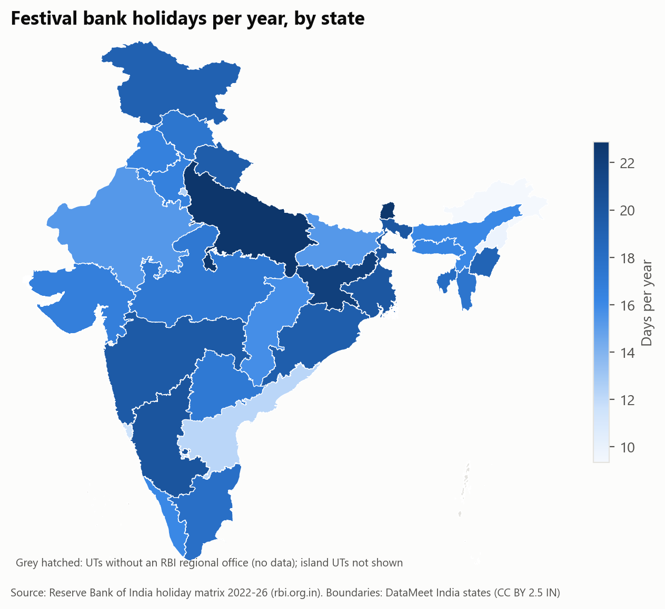
Fig. 4.7 Festival holidays recognised per year, by state.

PART 5 — Results and Conclusion

5.1 Summary of Results
Model / Method | Main Metric | Value | Key Finding
Model 1: Log-linear regression (festive trade) | RMSE; R-squared; MAPE (leave-one-out) | Rs 35,908 crore; 0.96; 20% | Reported festive trade grows about 36% a year; 2026 Holi figure predicted within 3%.
Model 2: Random Forest (tradition of a festival) | Accuracy; macro F1 (repeated 5-fold CV) | 0.51; 0.45 (baseline F1 0.15) | Date and footprint reveal a festival's tradition only partly: nationwide festivals of every faith look alike.
Model 3: K-Means (grouping states) | Silhouette score | 0.50 for 2 groups | Manipur, Meghalaya, Mizoram, Nagaland have a distinct calendar; the rest of India is a continuum, not regional blocks.
Statistical Test: paired t-test (actual vs predicted) | t statistic; p-value | t = -0.19, df = 14; p = 0.85 | Fail to reject H₀: no systematic bias in the trade predictions.
Supporting test: Spearman correlation | rho across 29 states | 0.38 to 0.66 (all p < 0.05) | Holiday calendars follow demography, yet are more plural: Hindu festivals are 49% of festival holidays vs 79.8% of population.
Forecasting: festive trade 2026 | Model forecast (INR crore) | Diwali 764,209; Holi 96,061; Karva Chauth 38,534 | Extrapolation of the growth trend; based on 15 data points, so indicative only.
Conclusion
Using only authentic, source-linked data, the project shows that India's officially recognised festival calendar peaks in April, October and March; that each faith's share of a state's holidays follows its population share while the calendar as a whole is more plural than the population; that Uttar Pradesh, Sikkim and Jharkhand recognise the most festival holidays; and that reported festive trade is growing at about 36% a year. The trade model predicts unseen figures without systematic bias (paired t-test), though individual errors average about a fifth. An important limitation is itself a finding: national spending estimates are published mainly for Hindu festivals, so the economic comparison across traditions is incomplete. Bank holidays measure official recognition, not participation, and 19 of 101 festivals that always share their date remain uncertain and are flagged.

5.2 Future Scope
- Larger and more diverse dataset: add state-government holiday gazettes and restricted holidays, so festivals without a bank holiday and union territories without an RBI office are covered.
- Additional features: district-level footfall, tourism arrivals, rail and air passenger counts, and GST or e-commerce data around each festival.
- Alternative ML algorithms: gradient boosting and multi-label classification, since many festivals belong to more than one tradition.
- Ensemble and advanced modelling: hierarchical (mixed-effects) or Bayesian models for trade, which handle few data points per festival better.
- Real-time data collection: re-collect the RBI list every month, so late-declared holidays and each new year are added automatically.
- Deployment: publish the interactive state map and month timeline as a public web dashboard.

